Project Title: Ski Resort Gear Rental System
Course: CS340
Group: 80
Team Members: Joshua Cabalka, Jack Boland, Philip Gadsden
Project Step 5 Draft Version
Date: 03/9/2026

- Project URL: http://classwork.engr.oregonstate.edu:40405

- Feedback from Step 4 Draft:
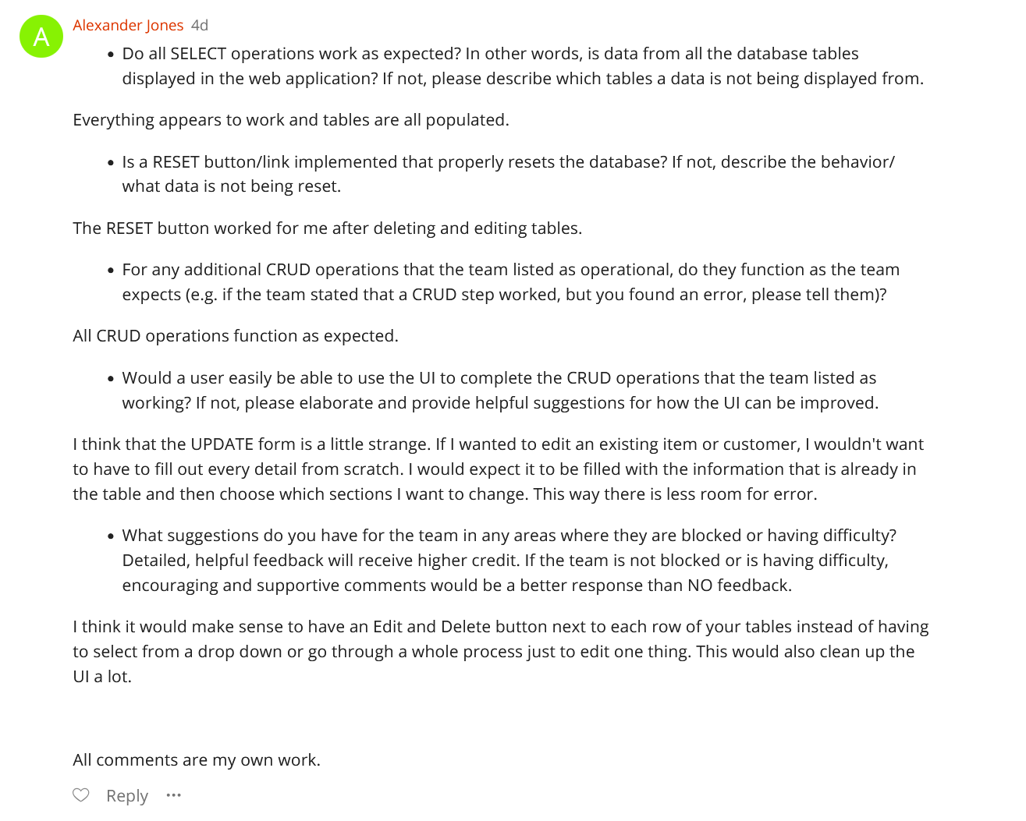
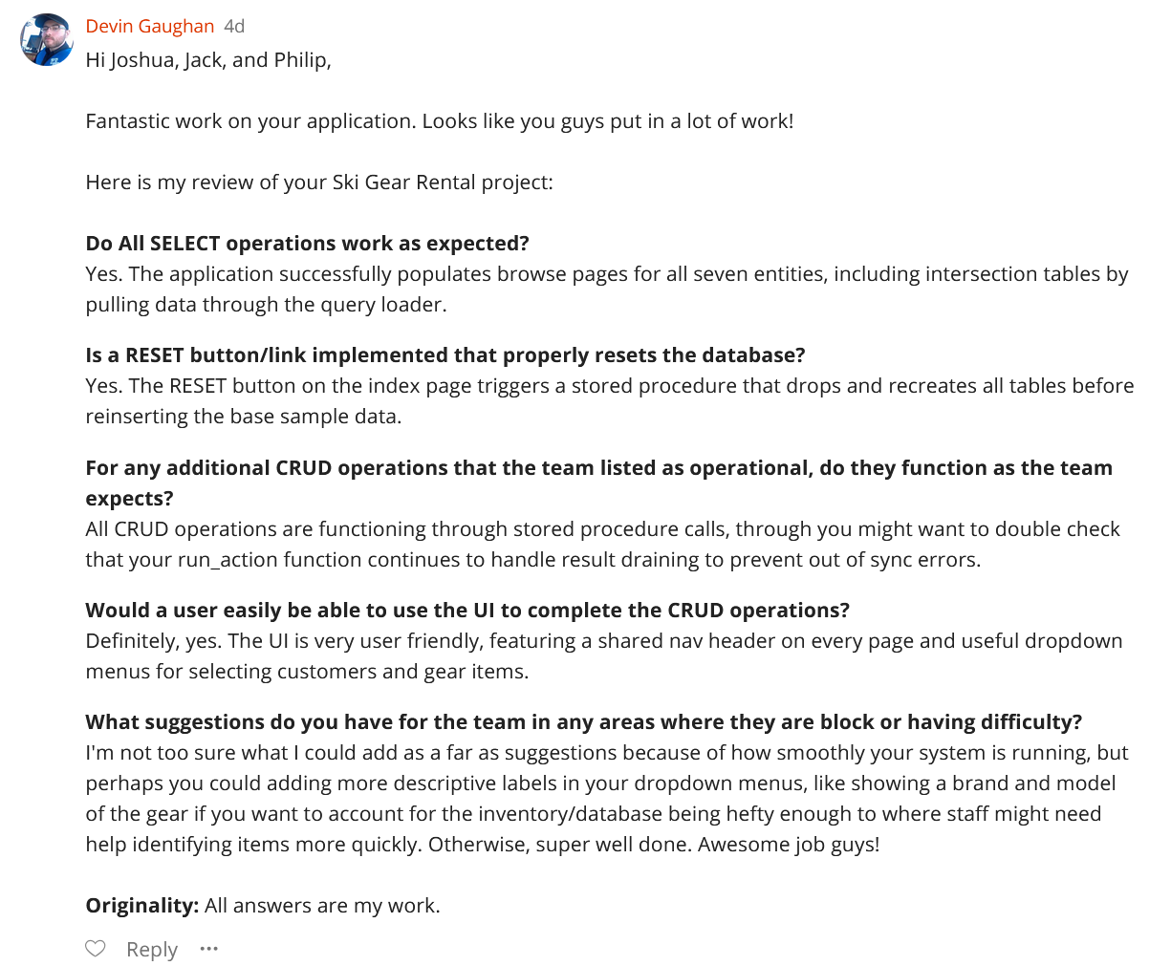
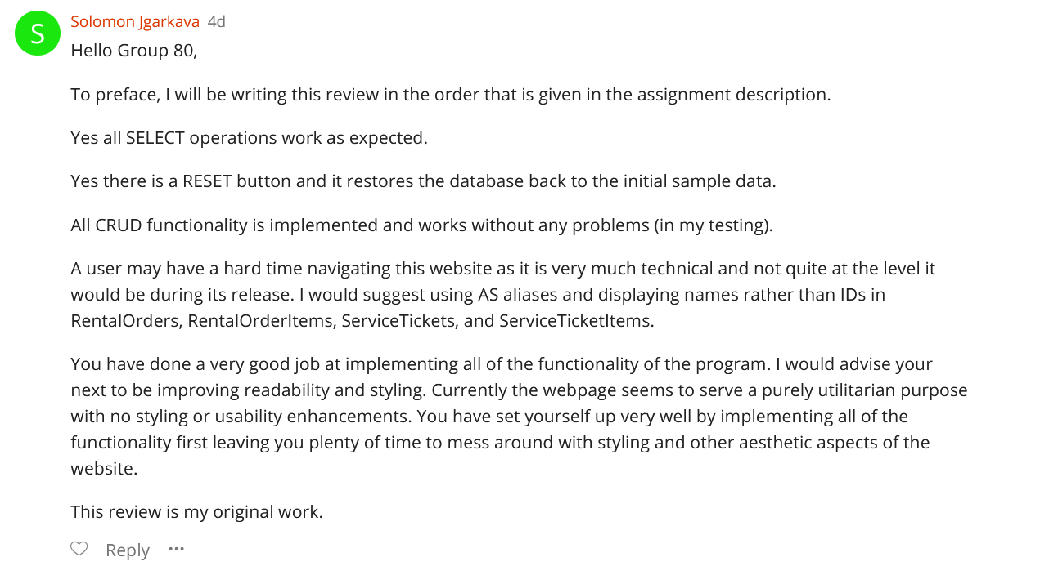
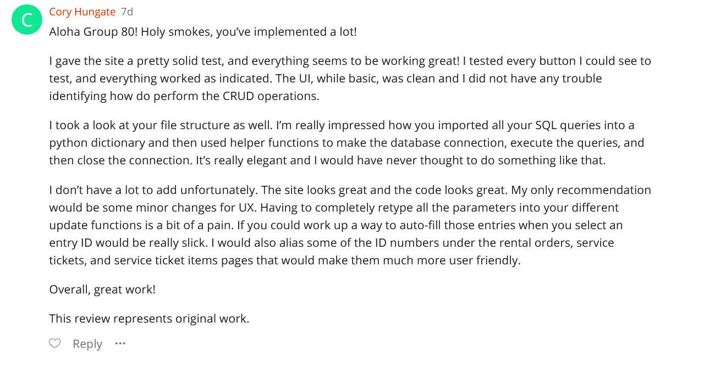

c) Changes based on feedback from step 4 draft:
i) No changes were made based on the step 4 feedback for this draft. UI design and usability suggestions were considered but not deemed necessary for this submission since all of the required functionality is working and the current interface supports the required workflows.
d) Feedback from Step 3 Final
i) Grader feedback received: Step 3 PDF submission was missing the ERD.
e) Changes Based on Feedback from Step 3 Final
i) Added ERD to the PDF.

f) Fixes Based on Feedback from Step 3 Draft
    - Added a shared navigation header on all pages to make it easier for users to move between pages without having to return to the index.
    - DELETE operations properly implemented.

g) Design Changes from Step 3
    - Added DB reset stored procedure in its own SQL file. The DML file calls it when the UI frontend requests it. There is a single reset button on the main index.html page that will reset the database to just the example data.

    - Converted all CRUD operations into stored procedures and stored them in a separate SQL file. Updated DML file to call procedures from the procedures file.
    - Fixed run_action function to safely handle stored procedure calls by draining results set to avoid errors.
    - Fixed UI schema enum mismatches.

h) Fixes Based on Feedback from Step 2

Feedback based on the Step 2 submission was positive, with many reviewers noting that the system design, entities, relationships, ERD and Schema were clear and aligned with project requirements. No major changes were made to the Schema or SQL.

i) Fixes Based on Feedback from Step 1

Feedback on the Step 1 submission was mainly positive, with reviewers agreeing that the system design, entities, relationships, and ERD were clear and aligned with requirements. Only minor issues were identified and addressed.

Reviewers noted that the overview could better illustrate system scale. The overview was updated to more explicitly describe operational scope, including individual gear tracking, multi-item rental orders, historical checkout and return records, and independent maintenance workflows.

An error was identified in the database outline where customer_id in the rental_orders table incorrectly referenced the employees table. This was corrected to reference customers(customer_id), aligning the outline with the ERD and business logic.

A minor naming inconsistency was identified in the rental_order_items table, where the foreign key name did not match the rental order primary key naming convention. Fixed foreign key reference so rental_orders.customer_id correctly references customers(customer_id).

Clarified meaning of employees.is_active (employee is currently employed/authorized to create orders and service tickets).

No other changes were required, as reviewers confirmed that entity modeling, relationships, naming conventions, and the ERD were correct.

j) Project Overview and Database Outline

This project models an admin-facing ski resort gear rental system designed to manage an equipment inventory of approximately 300 individual gear items across various categories, along with an average of 80 rental transactions per week and 20 maintenance service tickets per week.

The system tracks individual gear items to allow staff to monitor availability, condition, rental history, and service history at the item level. Rental activity is recorded through rental orders created by employees for customers, with each rental order capable of containing multiple gear items. A typical rental order contains 2–4 gear items. Historical rental data is preserved using timestamps that record when items are checked out and returned.

Maintenance and repair work is tracked independently using service tickets, which document service procedures performed on one or more gear items. Each service ticket includes timestamps for work start and completion, allowing the system to maintain a complete maintenance history separate from rental activity. Together, these components support both daily operational needs and long-term inventory and service tracking for the ski resort.

Database Outline

- customers: Records customers who rent gear from the ski resort.

Attributes
- customer_id: INT, AUTO_INCREMENT, PRIMARY KEY, NOT NULL
- first_name: VARCHAR(100), NOT NULL
- last_name: VARCHAR(100), NOT NULL
- phone: VARCHAR(20), NULL
- email: VARCHAR(255), NULL

Relationships
- One-to-many (1:M) relationship with rental_orders

- employees: Records employees who create rental orders and service tickets.

Attributes
- employee_id: INT, AUTO_INCREMENT, PRIMARY KEY, NOT NULL
- first_name: VARCHAR(100), NOT NULL
- last_name: VARCHAR(100), NOT NULL
- role: VARCHAR(50), NOT NULL
- is_active: BOOLEAN, NOT NULL, DEFAULT TRUE
- Indicates whether the employee is currently employed and authorized to create rental orders and service tickets

Relationships
- One-to-many (1:M) relationship with rental_orders
- One-to-many (1:M) relationship with service_tickets

- gear_items: Records each physical piece of ski or snowboard-related equipment.

Attributes
- gear_item_id: INT, AUTO_INCREMENT, PRIMARY KEY, NOT NULL
- category: ENUM(‘snowboard’, ‘boots’, ‘helmet’, ‘other’), NOT NULL
- brand: VARCHAR(100), NOT NULL
- model: VARCHAR(100), NOT NULL
- serial_number: VARCHAR(100), UNIQUE, NOT NULL
- size: VARCHAR(20), NOT NULL
- condition_grade: ENUM(‘new’, ‘good’, ‘fair’, ‘needs_repair’), NOT NULL
- status: ENUM(‘available’, ‘rented’, ‘in_service’, ‘retired’), NOT NULL
- acquired_at: DATETIME, NOT NULL

Relationships
- Many-to-many (M:M) relationship with rental_orders
- Many-to-many (M:M) relationship with service_tickets

- rental_orders: Records each rental checkout transaction.

Attributes
- rental_order_id: INT, AUTO_INCREMENT, PRIMARY KEY, NOT NULL
- customer_id: INT, NOT NULL, FOREIGN KEY → customers(customer_id)
- created_by_employee_id: INT, NOT NULL, FOREIGN KEY → employees(employee_id)
- created_at: DATETIME, NOT NULL

Relationships
- Many-to-one (M:1) relationship with customers
- Many-to-one (M:1) relationship with employees
- Many-to-many (M:M) relationship with gear_items (via rental_order_items)

- service_tickets: Records maintenance and repair work performed on gear items.

Attributes
- service_ticket_id: INT, AUTO_INCREMENT, PRIMARY KEY, NOT NULL
- opened_by_employee_id: INT, NOT NULL, FOREIGN KEY → employees(employee_id)
- status: ENUM(‘open’, ‘in_progress’, ‘completed’, ‘canceled’), NOT NULL
- created_at: DATETIME, NOT NULL

Relationships
- Many-to-one (M:1) relationship with employees
- Many-to-many (M:M) relationship with gear_items (via service_ticket_items)

Intersection Tables

- rental_order_items: Implements the many-to-many relationship between rental_orders and gear_items.

Attributes
- rental_order_id: INT, NOT NULL, FOREIGN KEY → rental_orders(rental_order_id)
- gear_item_id: INT, NOT NULL, FOREIGN KEY → gear_items(gear_item_id)
- checked_out_at: DATETIME, NOT NULL
- due_at: DATETIME, NOT NULL
- returned_at: DATETIME, NULL

Primary Key
- (rental_order_id, gear_item_id)

Business Rule
- A gear item may only appear in one active rental at a time. This is enforced by checking that gear_items.status = 'available' prior to checkout and updating the status to 'rented' while returned_at is NULL.

- service_ticket_items: Implements the many-to-many relationship between service_tickets and gear_items.

Attributes
- service_ticket_id: INT, NOT NULL, FOREIGN KEY → service_tickets(service_ticket_id)
- gear_item_id: INT, NOT NULL, FOREIGN KEY → gear_items(gear_item_id)
- service_type: ENUM(‘wax’, ‘tune’, ‘repair’, ‘binding_adjust’, ‘inspect’), NOT NULL
- started_at: DATETIME, NULL
- completed_at: DATETIME, NULL

Primary Key
- (service_ticket_id, gear_item_id)

k) Entity-Relationship Diagram (ERD)

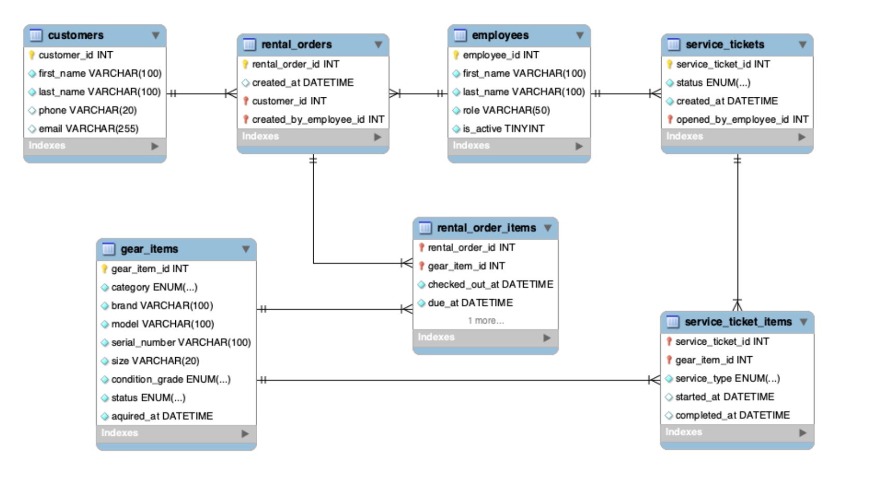

l) Schema Diagram + Normalization (Write-up)

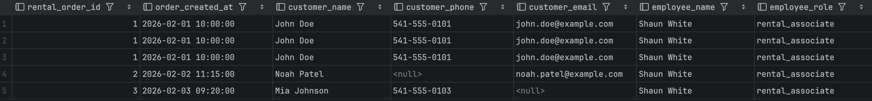
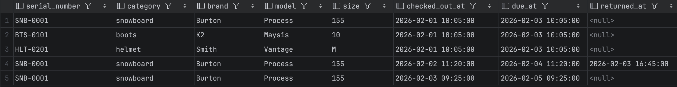
The following report was generated by joining rental orders, customers, employees, and gear items into a single flattened result set, where each row represents a gear item within a rental order. This report reflects how the data might appear in a spreadsheet prior to normalization.
Figure 2: Unnormalized rental activity sample report demonstrating data redundancy and update/insert/delete anomalies prior to normalization.

In the sample report, order-level, customer, and employee attributes are repeated across multiple rows because each row represents a single gear item within a rental order. For example, rental order 1 appears three times, resulting in duplicated customer and employee data. This redundancy introduces update anomalies (e.g., a change to a customer’s contact information must be applied to multiple rows), insert anomalies (new customers, gear items, or employees cannot be added independently without creating a full rental transaction), and delete anomalies (removing the final line item for an order may unintentionally remove associated order or customer information).

To convert the design to First Normal Form (1NF), repeating groups were eliminated by separating rental order data from individual gear items. Each rental order may contain multiple gear items, so a separate intersection table was introduced to represent one row per gear item per order. The composite key (rental_order_id, gear_item_id) uniquely identifies each row. With atomic attributes and no repeating groups, the design satisfies 1NF.

In the 1NF design, partial dependencies existed because order-level attributes depended only on rental_order_id, while gear attributes depended only on gear_item_id. To convert the design to Second Normal Form (2NF), these partial dependencies were removed by decomposing the schema into rental_orders, gear_items, and rental_order_items. Each non-key attribute now depends on the entire primary key of its table.

Transitive dependencies were identified where customer and employee attributes depended on non-key identifiers in rental orders (e.g., rental_order_id → customer_id → customer attributes). These dependencies were eliminated by moving customer information into a customers table and employee information into an employees table, referenced by foreign keys. After this decomposition, all non-key attributes depend only on the primary key of their respective tables, and the schema satisfies Third Normal Form (3NF).
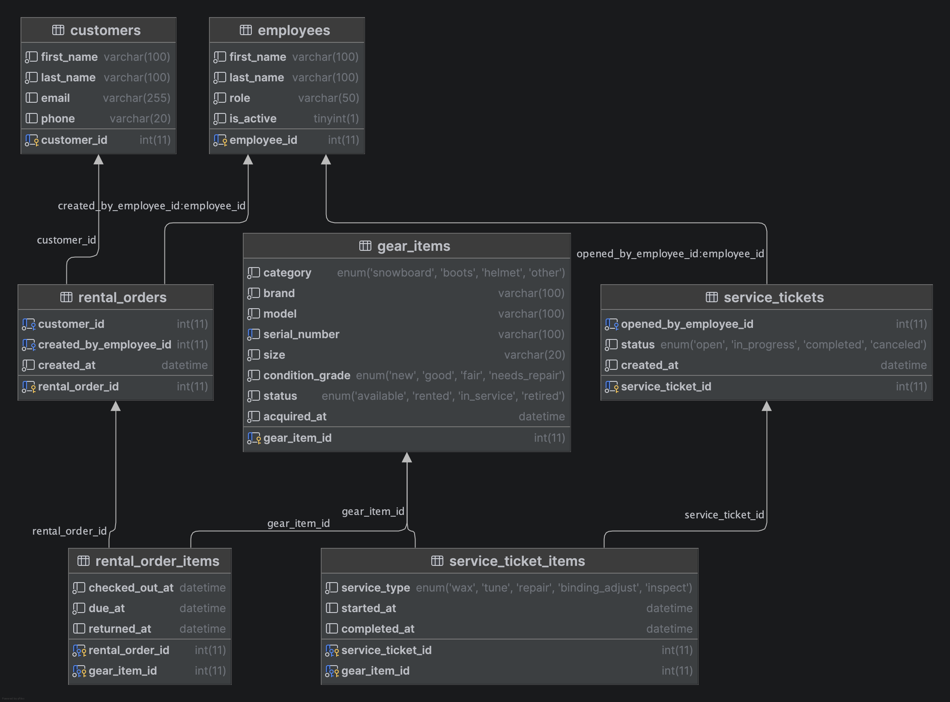
Figure 3: Final normalized database schema for the ski resort gear rental system.

m) Example Data

customers

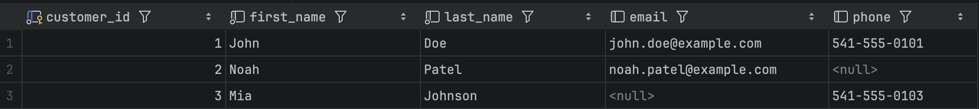
employees
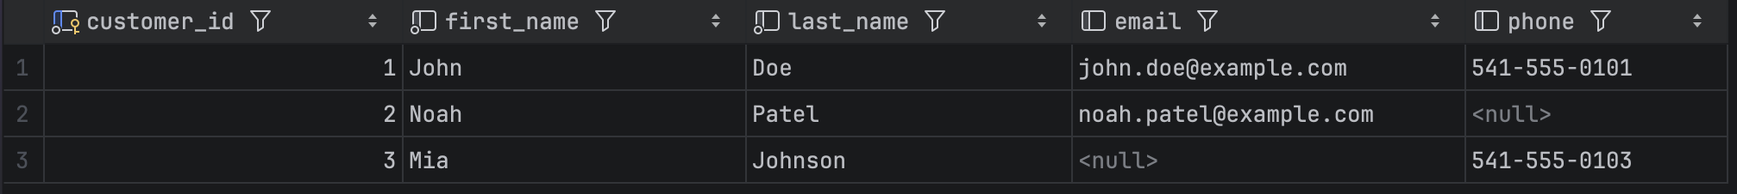
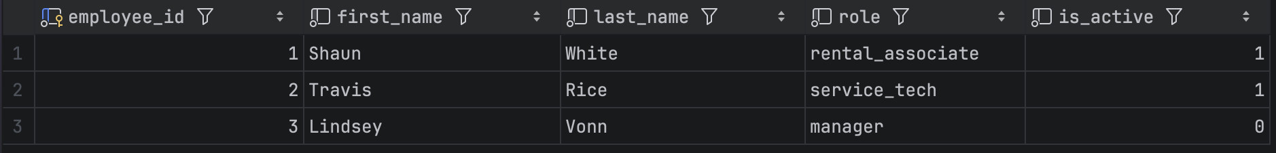
gear_items

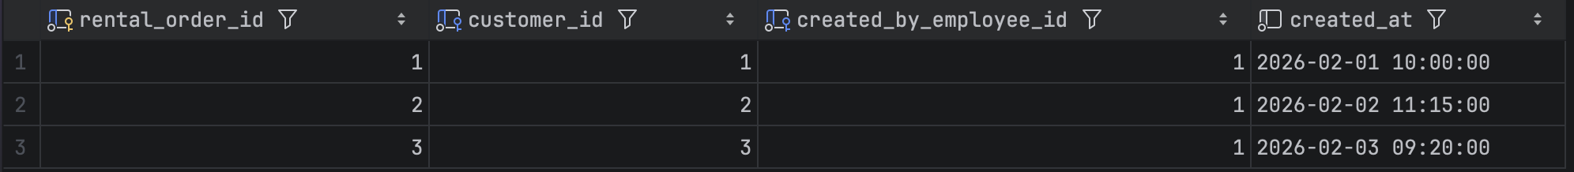
rental_orders
rental_order_items
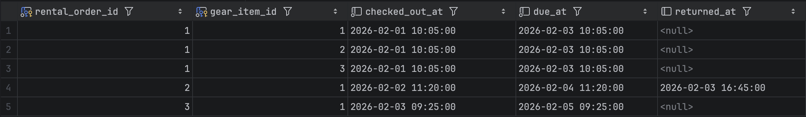

service_ticket_items
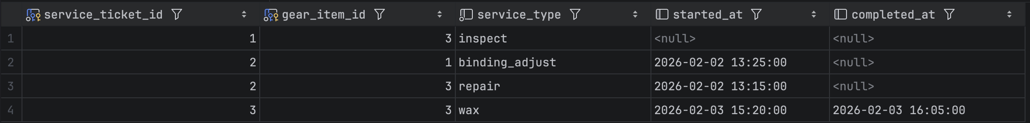

service_tickets
